# Time Series in-class test for Full Time DSE

**(Duration 2 hours)**

1. The quarterly gross domestic product series shown below has which components of a time series?
   1. Trend only
   2. Seasonality only
   3. Both Trend and seasonality
   4. None can be identifiable

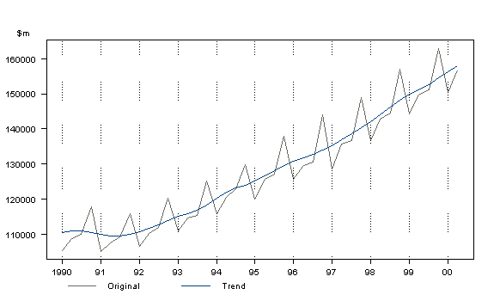

1. If a quarterly time series has additive seasonality, then find out the missing value

|  |  |  |  |
| --- | --- | --- | --- |
| **Q1** | **Q2** | **Q3** | **Q4** |
| **25** | **-5** |  | **10** |

1. The dataset Australian Wine Sales contains monthly sales of 3 different varieties of wines (sparkling, sweet white and red) from 1980 January to 1995 July.
   1. Read the data in R
   2. Smooth the series of sweet white sales with an appropriate moving average. Plot both the original and moving average on the same graph, preferably using different colors.
   3. Do month plot on both sparkling and red wine series. Which is the main difference noted between the two series?
   4. Extract seasonality for both series. Argue which seasonality (additive or multiplicative) will be appropriate for which series. Plot only the seasonality.
   5. Forecast for sparkling wine sales for next 12 months. Explain the model and write down the model parameters.